Year
# Source: AI Source: Provided by: [Data Path: Persons Table -> ID Column: 1, Name_En Column: Motasem Essam] -> From: [ChatGPT] on [7/17/2026]
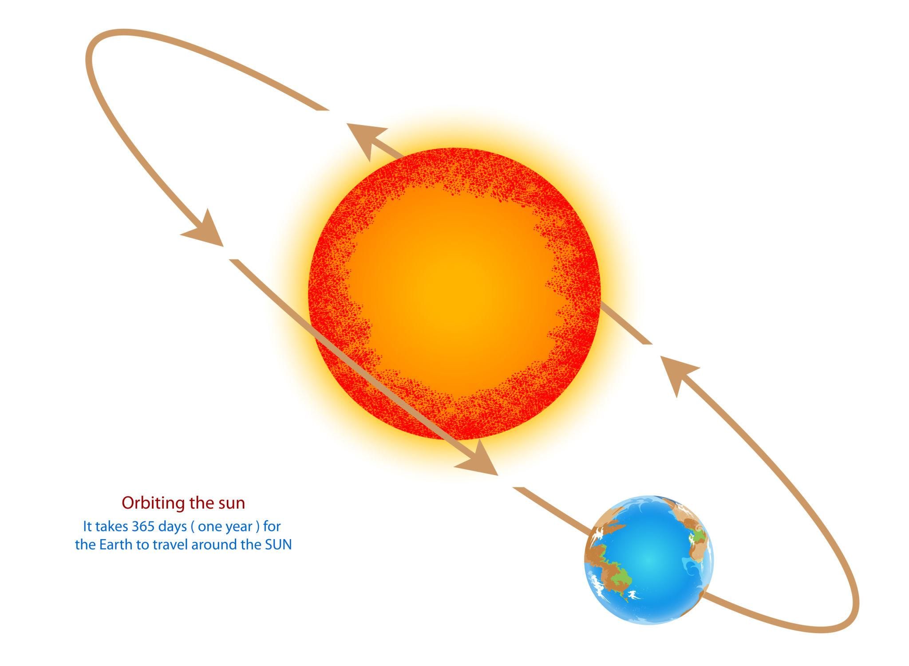
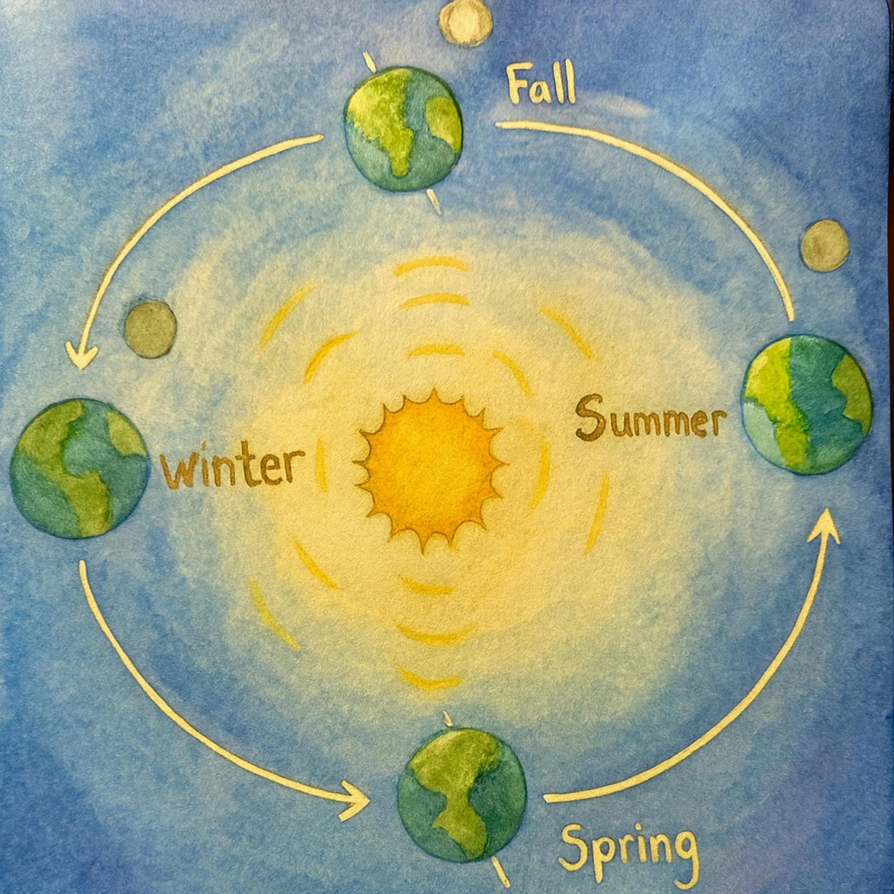
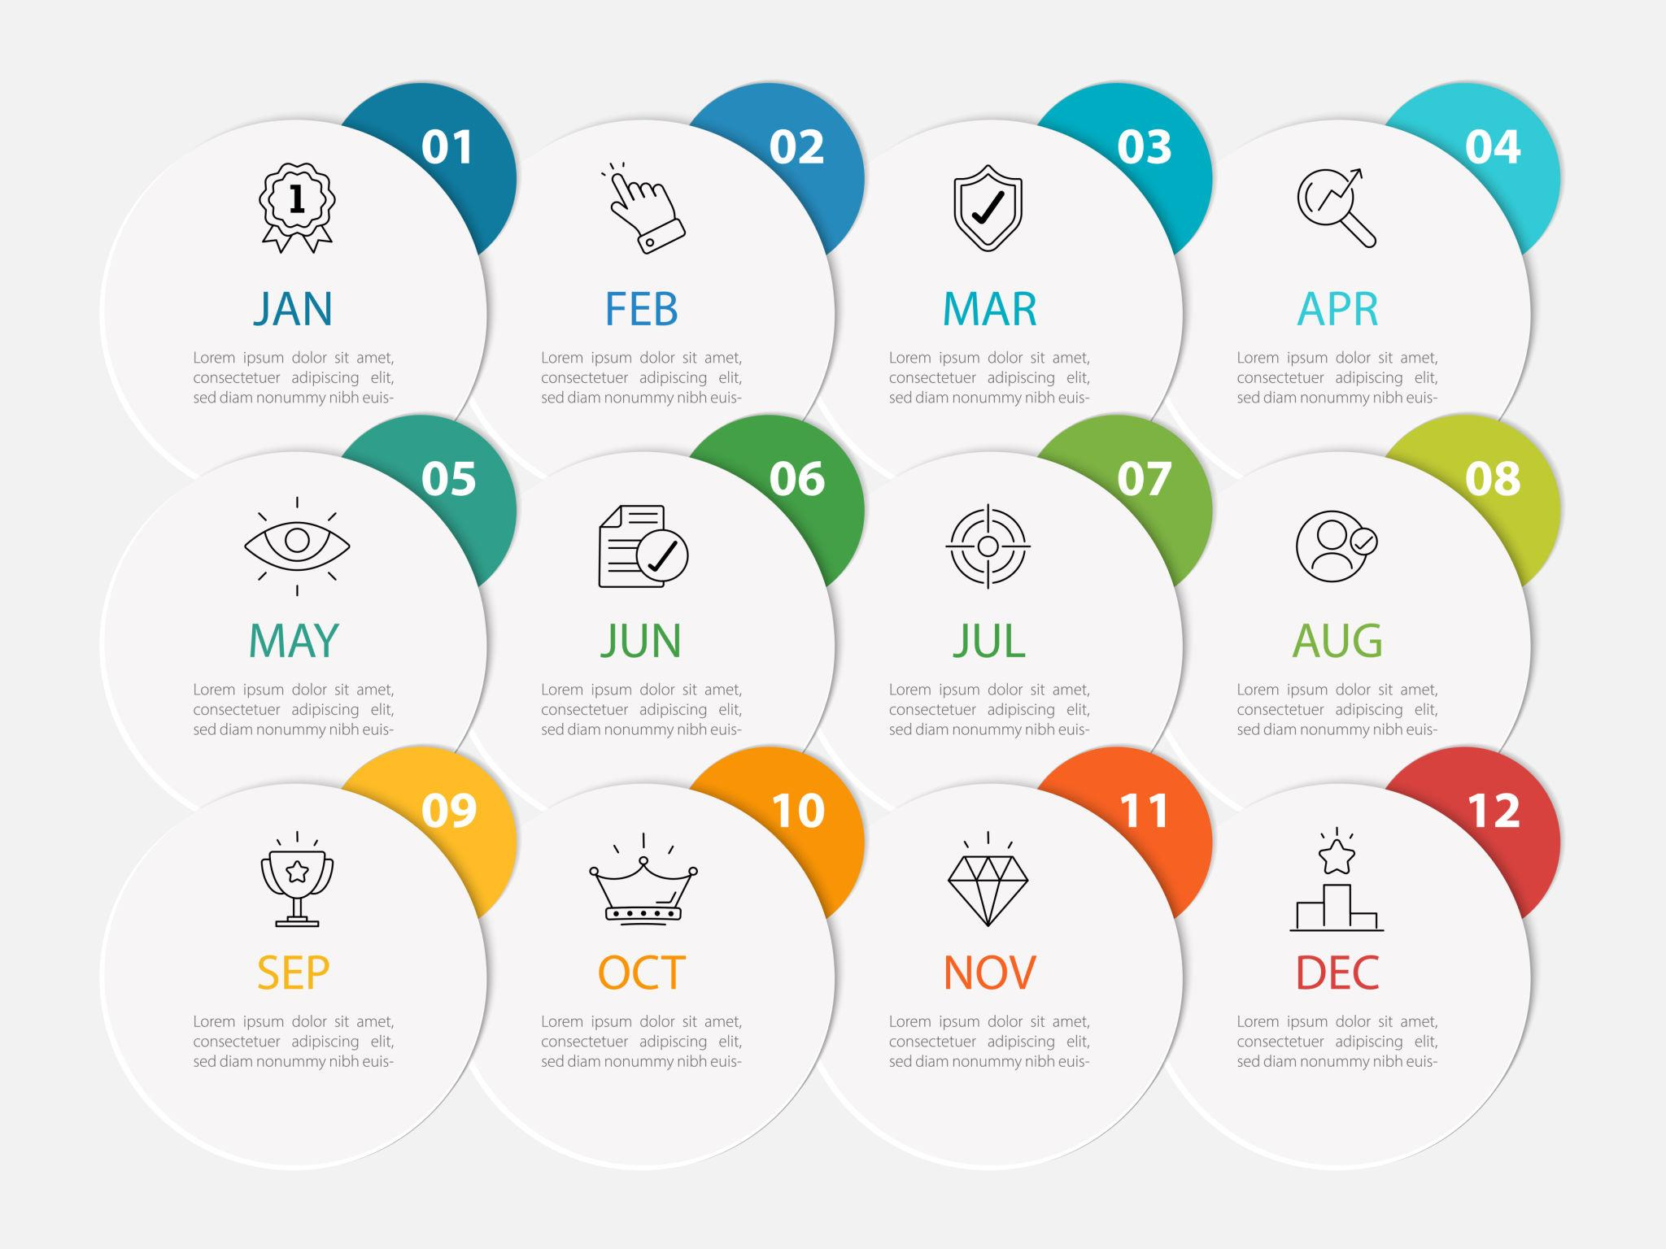
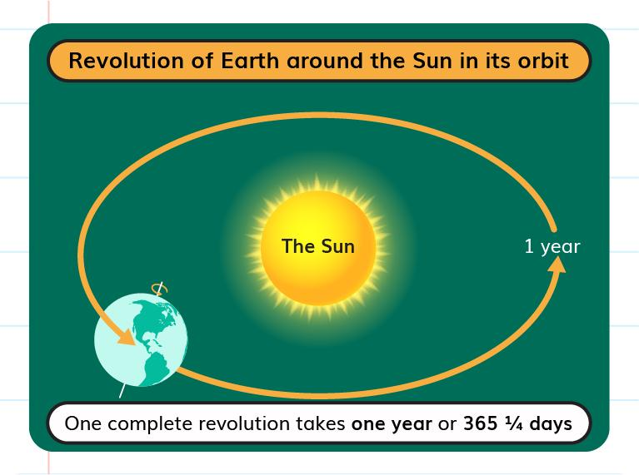
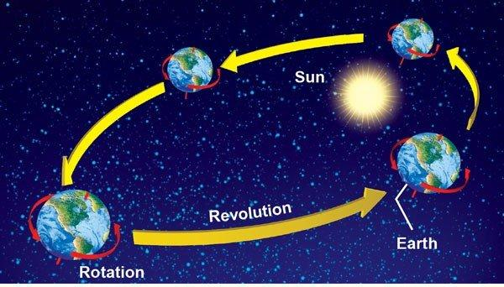
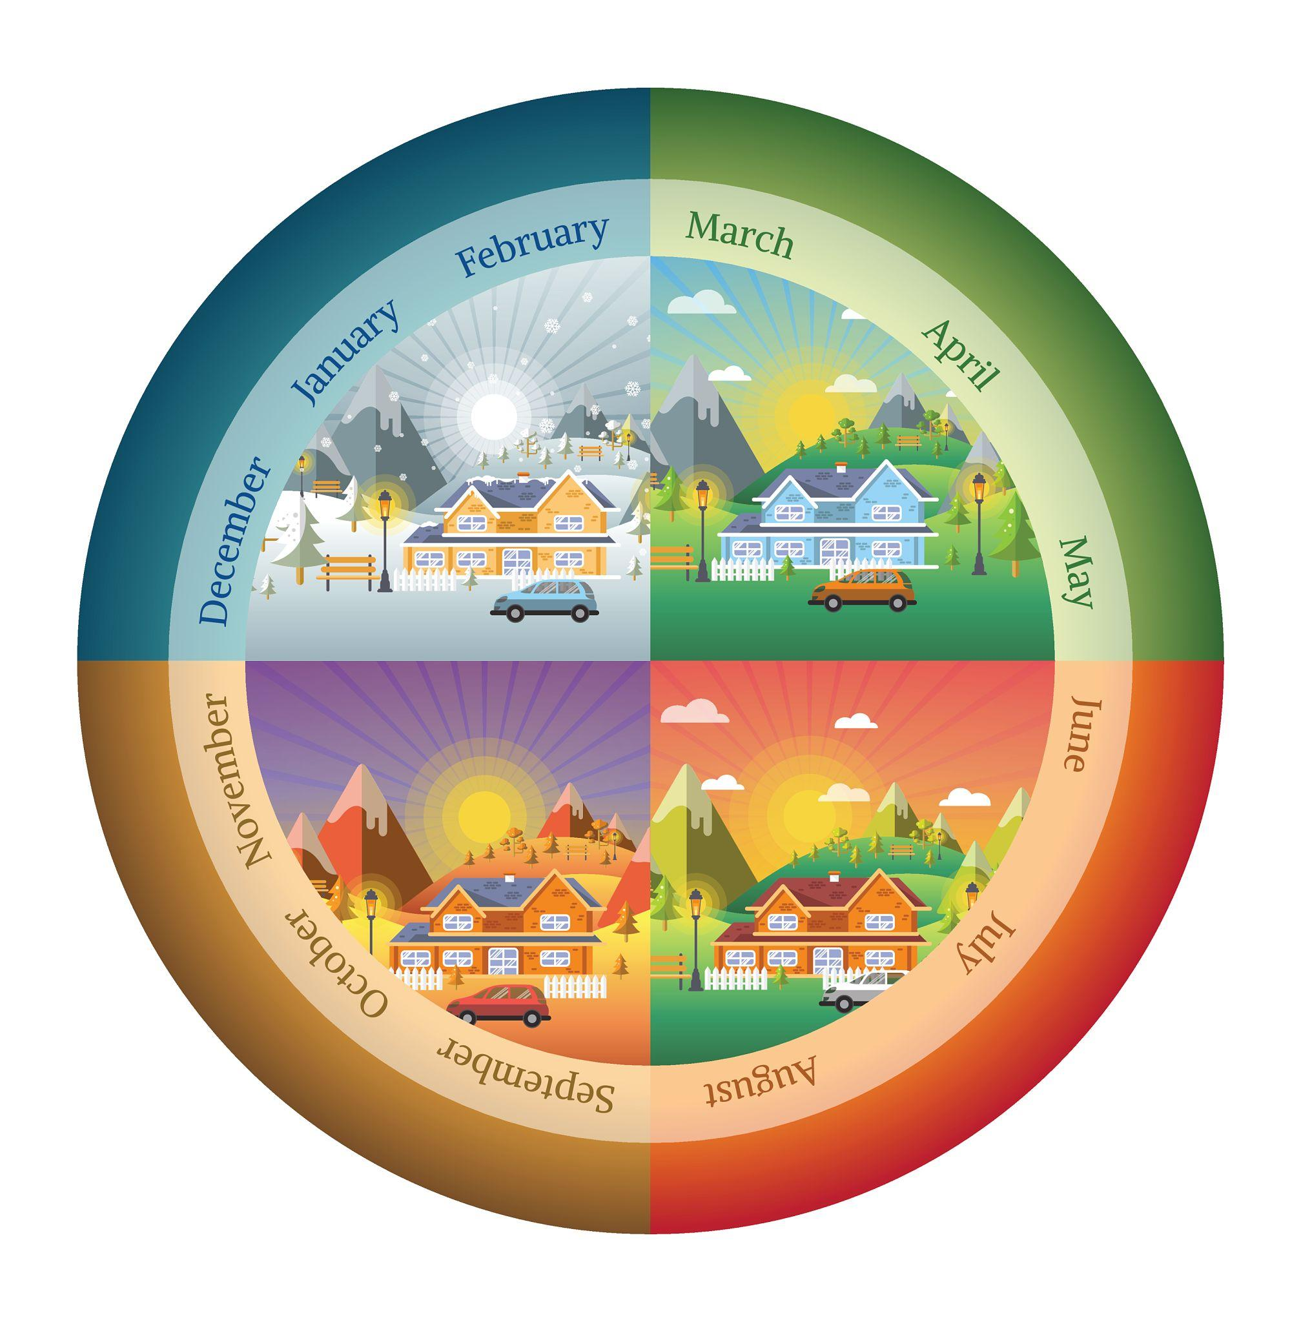
A Year is a unit of time representing the period required for the Earth to complete one full revolution around the Sun. It is one of the largest standard units of time used in calendars and serves as the basis for organizing seasons, calendars, historical records, education, business, and scientific observations.
A standard civil year in the Gregorian Calendar contains 365 days, while a leap year contains 366 days.

Definition
# Source: AI Source: Provided by: [Data Path: Persons Table -> ID Column: 1, Name_En Column: Motasem Essam] -> From: [ChatGPT] on [7/17/2026]
A Year is the time required for the Earth to complete one orbit around the Sun, commonly measured as 365 or 366 days in the Gregorian Calendar.

Astronomical Basis
# Source: AI Source: Provided by: [Data Path: Persons Table -> ID Column: 1, Name_En Column: Motasem Essam] -> From: [ChatGPT] on [7/17/2026]
A year is based on:
- The Earth's revolution around the Sun.
The average length of one tropical (solar) year is:
$$365.2422\text{ days}$$
Because this is not exactly 365 days, leap years are used to keep the calendar aligned with the seasons.

Standard Length
# Source: AI Source: Provided by: [Data Path: Persons Table -> ID Column: 1, Name_En Column: Motasem Essam] -> From: [ChatGPT] on [7/17/2026]
Common Year
- 365 days
Leap Year
- 366 days

Structure of a Year
# Source: AI Source: Provided by: [Data Path: Persons Table -> ID Column: 1, Name_En Column: Motasem Essam] -> From: [ChatGPT] on [7/17/2026]
A standard year contains:
- 12 months
- 52 weeks
- 365 days
A leap year contains:
- 12 months
- 52 weeks + 2 days
- 366 days

Relationship to Other Time Units
# Source: AI Source: Provided by: [Data Path: Persons Table -> ID Column: 1, Name_En Column: Motasem Essam] -> From: [ChatGPT] on [7/17/2026]
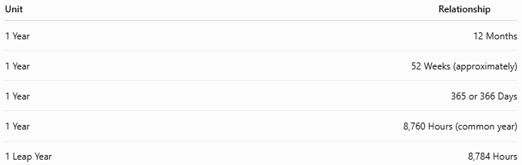
Unit | Relationship
1 Year | 12 Months
1 Year | 52 Weeks (approximately)
1 Year | 365 or 366 Days
1 Year | 8,760 Hours (common year)
1 Leap Year | 8,784 Hours

Leap Year
# Source: AI Source: Provided by: [Data Path: Persons Table -> ID Column: 1, Name_En Column: Motasem Essam] -> From: [ChatGPT] on [7/17/2026]
A leap year adds one extra day to:
- February
Resulting in:
- 29 days instead of 28
Gregorian Leap-Year Rule
A year is a leap year if:
- It is divisible by 4,
except years divisible by 100, unless they are also divisible by 400.
Examples:

Year | Leap Year?
2024 | ✔ Yes
2025 | ✘ No
1900 | ✘ No
2000 | ✔ Yes

Types of Years

1. Calendar Year
# Source: AI Source: Provided by: [Data Path: Persons Table -> ID Column: 1, Name_En Column: Motasem Essam] -> From: [ChatGPT] on [7/17/2026]
The year used in a calendar system.
Example:
- 2026

2. Solar Year (Tropical Year)
# Source: AI Source: Provided by: [Data Path: Persons Table -> ID Column: 1, Name_En Column: Motasem Essam] -> From: [ChatGPT] on [7/17/2026]
The time required for the Earth to return to the same position relative to the seasons.
Average length:
$$365.2422\text{ days}$$

3. Sidereal Year
# Source: AI Source: Provided by: [Data Path: Persons Table -> ID Column: 1, Name_En Column: Motasem Essam] -> From: [ChatGPT] on [7/17/2026]
The time required for the Earth to complete one orbit relative to the distant stars.
Average length:
$$365.2564\text{ days}$$

4. Lunar Year
# Source: AI Source: Provided by: [Data Path: Persons Table -> ID Column: 1, Name_En Column: Motasem Essam] -> From: [ChatGPT] on [7/17/2026]
A year consisting of 12 lunar months.
Average length:
$$354.37\text{ days}$$
Used in:
- Islamic (Hijri) Calendar

5. Lunisolar Year
# Source: AI Source: Provided by: [Data Path: Persons Table -> ID Column: 1, Name_En Column: Motasem Essam] -> From: [ChatGPT] on [7/17/2026]
A year consisting of 12 or 13 lunar months, adjusted with leap months to remain aligned with the seasons.
Used in:
- Hebrew Calendar
- Chinese Calendar
- Traditional Hindu Calendars

Applications
# Source: AI Source: Provided by: [Data Path: Persons Table -> ID Column: 1, Name_En Column: Motasem Essam] -> From: [ChatGPT] on [7/17/2026]
Years are used in:
- Calendars
- Education
- Government
- Business
- Finance
- Science
- Astronomy
- Historical records
- Age calculation

Importance
# Source: AI Source: Provided by: [Data Path: Persons Table -> ID Column: 1, Name_En Column: Motasem Essam] -> From: [ChatGPT] on [7/17/2026]
The year provides a framework for:
- Measuring long periods of time.
- Organizing seasons.
- Planning agriculture.
- Tracking historical events.
- Scheduling education and business activities.

Advantages
# Source: AI Source: Provided by: [Data Path: Persons Table -> ID Column: 1, Name_En Column: Motasem Essam] -> From: [ChatGPT] on [7/17/2026]
Using years allows people to:
- Organize time consistently.
- Predict seasonal changes.
- Record historical chronology.
- Plan long-term projects.
- Coordinate activities worldwide.

Common Mistakes
# Source: AI Source: Provided by: [Data Path: Persons Table -> ID Column: 1, Name_En Column: Motasem Essam] -> From: [ChatGPT] on [7/17/2026]
- Assuming every year has exactly 365 days.
- Forgetting leap years.
- Confusing solar years with lunar years.
- Assuming all calendar systems define a year in the same way.

Comparison of Year Types
# Source: AI Source: Provided by: [Data Path: Persons Table -> ID Column: 1, Name_En Column: Motasem Essam] -> From: [ChatGPT] on [7/17/2026]
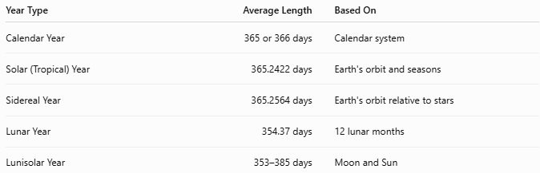
Year Type | Average Length | Based On
Calendar Year | 365 or 366 days | Calendar system
Solar (Tropical) Year | 365.2422 days | Earth's orbit and seasons
Sidereal Year | 365.2564 days | Earth's orbit relative to stars
Lunar Year | 354.37 days | 12 lunar months
Lunisolar Year | 353–385 days | Moon and Sun

Interesting Facts
# Source: AI Source: Provided by: [Data Path: Persons Table -> ID Column: 1, Name_En Column: Motasem Essam] -> From: [ChatGPT] on [7/17/2026]
- The Earth travels approximately 940 million kilometers (584 million miles) around the Sun each year.
- The Earth's average orbital speed is about 29.8 km/s (107,000 km/h).
- Leap years prevent the calendar from drifting away from the seasons.

Key Points
# Source: AI Source: Provided by: [Data Path: Persons Table -> ID Column: 1, Name_En Column: Motasem Essam] -> From: [ChatGPT] on [7/17/2026]
- A Year is one complete revolution of the Earth around the Sun.
- A common year contains:
  - 365 days
- A leap year contains:
  - 366 days
- One year includes:
  - 12 months
  - Approximately 52 weeks
- Different calendar systems define years differently:
  - Solar
  - Lunar
  - Lunisolar

Conclusion
# Source: AI Source: Provided by: [Data Path: Persons Table -> ID Column: 1, Name_En Column: Motasem Essam] -> From: [ChatGPT] on [7/17/2026]
A Year is one of the fundamental units of time, representing the Earth's complete journey around the Sun. In the Gregorian Calendar, it consists of 365 days, with an additional day added during leap years to maintain alignment with the Earth's actual orbital period of approximately 365.2422 days. The concept of the year provides the foundation for calendars, seasons, historical chronology, education, business, and scientific observation, making it one of the most important measurements of time used throughout the world.

